Game Design Document

Fill up the following document

1. Write the title of your project.

* Doraemon’s running game.

1. What is the goal of the game?

The goal of the game is to collect all the gadgets and to reach the home.

1. Write a brief story of your game.

Story is that you have to choose a character in game and other character will be computer then you have to click on the play button

Now the game will start in the game for ex:- you choose “nobita” so you have to run and on the

way you will get many gadgets you have to collect them and to reach home .

1. Which are the playing characters of this game?

* Playing characters are the ones who respond to the user based on the input from the user.
* Cars, monkeys, dinos, wizards, etc., are the playing characters in the game.

|  |  |  |
| --- | --- | --- |
| Number | Character Name | What can this character do? |
| 1 | Nobita | Nobita will collect the gadgets and he will run away from the Gian. |
| 2 | Doraemon | Doraemon will do the same things as Nobita |
| 3 | Sizuka | Sizuka’ll do the same things as Nobita and Doraemon. |
| 4 | Dekisugi | Dekisugi will give them ideas and also do the same things as other charecters |
| 5 | Suneo | Suneo will also do the same things as the all charecters |
| 6 |  |  |
| 7 |  |  |
| 8 |  |  |

1. Which are the Non-Playing Characters of this game?

* Non-Playing characters are the ones that don't have an action or behavior when the user interacts with the game.
* Hurdles, stones, bananas, coins, etc., are non-playing characters in the game.

|  |  |  |
| --- | --- | --- |
| Number | Character Name | What can this character do? |
| 1 | streets | On streets PC will run. |
| 2 | school | At school they will hide or run. |
| 3 | mountains | On mountains they’ll hide |
| 4 | houses | All the PC have to reach there home to win |
| 5 | Gian | Gian will be in angry mood and he will run behind them and he’ll try to catch them.this character will operate by computer. |
| 6 | playground | Playground will be in the background |
| 7 |  |  |
| 8 |  |  |

Draw your imagination of this game. What does this game look like?

* Draw the game either on your computer or on paper.
* Add images of the game scenes to show each of the playing and non-playing characters at least once.

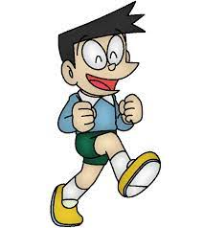



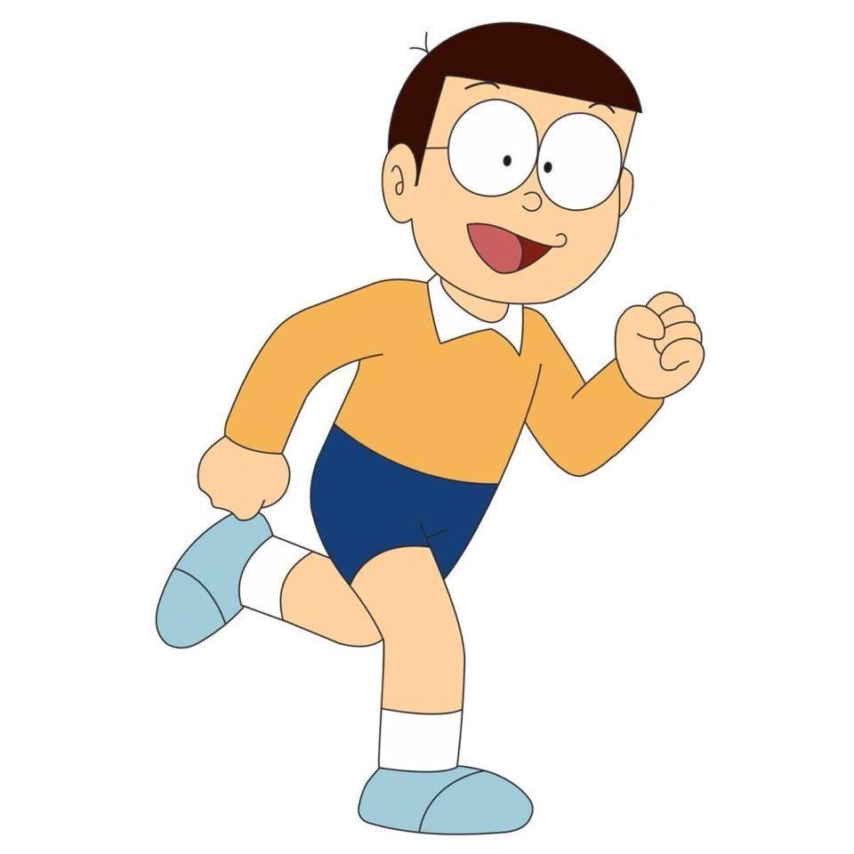

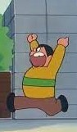  
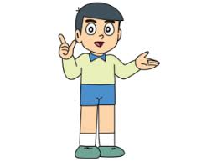

How do you plan to make your game engaging?